Access to Land Tenure for Food Enterprises in Liberia
A brief for policy makers

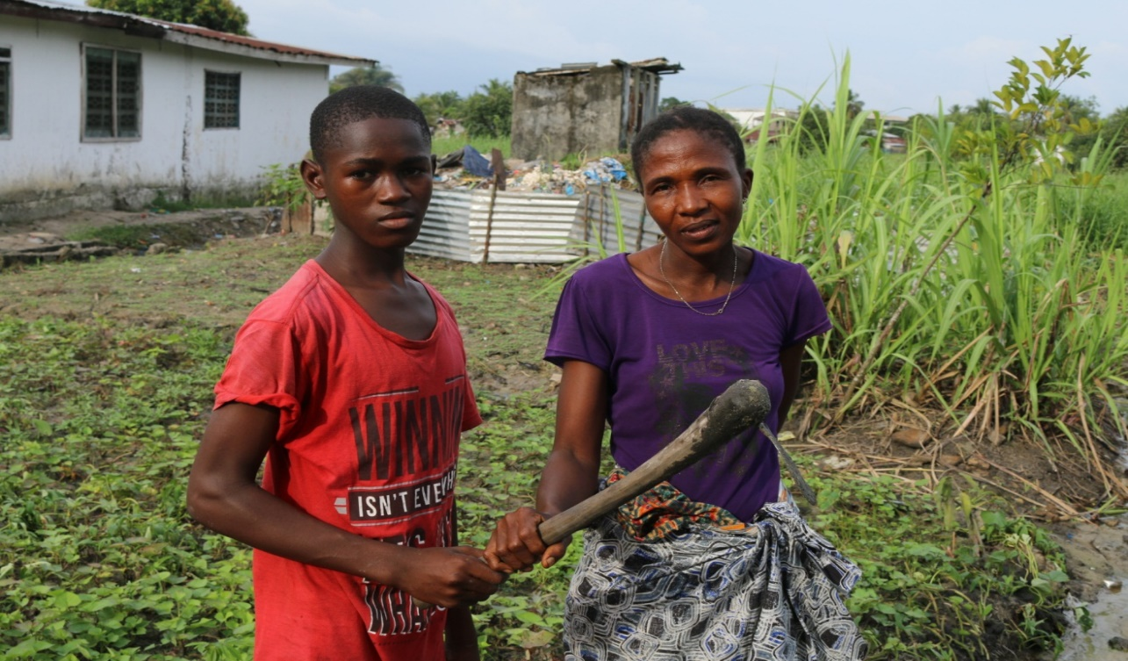
Above: James Bokai and his mother, Backyard Farmers, Chocolate City, Montserrado County, Liberia. James is a member of COME Liberia Accountability Forum.

f

EXECUTIVE SUMMARY
Equitable access to land is vital for inclusive economic growth, sustainable development, and food security in Liberia. When marginalized groups—especially young people are provided with equitable access to land it enables shifts in power relations and assure economic transformation for them and their communities.
This document addresses the need to secure access to land for young people to engage in agricultural activities in Liberia. It reveals the disadvantages of land privatization over public, protected and government owned lands. It further addresses the challenges that young people face as it pertains to access to land that is secure and makes recommendations. This policy brief argues that the accessibility and ownership of land is key to the development of youth-led agricultural social enterprises and makes specific recommendations for policies actions to address these challenges.

THE RIGHT TO LAND
There is a strong case for attracting more young people to the agricultural sector in Liberia, as the population continues to increase, and the rates of unemployment among young people skyrocket in both the urban and rural context. It is imperative that alternative means to employment and economic empowerment are provided to address these concerns - hence the need for increasing investments in agricultural development in rural and urban communities in Liberia. This can only be achieved when there is equal land access for young people in agricultural activities.
In Liberia, the right to land is regulated either by formal laws or customary laws. This is evidenced by the recently passed Land Rights Policy which recognizes the “practice as the law and policy, rather than the law and policy guiding the practice.” Most significantly, the policy aims to address historic inequalities by recommending that customary lands are given protection equal to that of private lands.
CUSTOMARY LAND TENURE
Customary land tenure refers to the relationship a society has created with respect to the use and ownership of real property. It often comes about through traditional practices within a community such as passing land down through inheritance or the practice of sharing common ground for grazing cattle or other farm animals. Customary laws allow certain families and clans to access land. But of late, migration of people from county to county adds to existing population pressures. Only people within the customary specifications have permission to access the land and to make use of the land the way they desire. This means that those who have not originally belonged in a territory might only be able to access the land on lease basis or not access it at all. In view of agricultural activities and food security, this means that only a few individual families who own land can determine how they use the land. This leaves the poor majority of agricultural groups unable to gain fair access to land.
PRIVATIZATION OF LAND
The new policy also states that, since 1824, “the Government of Liberia has treated all land that is not deeded as public,” regardless of occupancy, historic use, or intended use. As a result, rural communities have often been displaced and dispossessed of their lands while companies were awarded timber, mining and agricultural concessions. The physical occupants of the land were left without a stake in the negotiation process and without the ability to benefit from the proceeds. While Liberia bears large volumes of vacant and privately owned land, the government of Liberia recognizes and protects only private land rights. This leaves the majority of poor citizens who rely on agriculture for their living landless at the expense of a wealthy minority. This privatization of land only benefits certain individuals, since most private land owners do not fulfil their social responsibilities as defined in the law. Instead only a few individuals benefit from their activities (mostly through employment) leaving the rest to more suffering. Access to land for young people (especially women) has been particularly constrained.
ACCESS TO LAND FOR YOUTH
Unfavourable land tenure systems, the ongoing privatization and customary practices put most young people, and particularly women, at a disadvantage. In most of rural Africa, youth typically rely on inheritance and gifts, or informal land markets, to access land. However, population pressure—including a youth bulge in many developing countries—is leading to fragmentation of land, reducing land availability for youth and, potentially, opportunities to work in agriculture. Pessimistic views on inheritance prospects have encouraged youth to transition to non-agricultural activities.
Understanding how land inheritance affects such decisions is critical for understanding the likely impacts of demographic and technological change on development. Furthermore, there is a lack of provisions for youth in government land redistribution programs.
POLICY IMPLICATIONS AND RECOMMENDATIONS
This policy brief argues that the accessibility and ownership of land is key to the development of youth-led agricultural social enterprises. Promoting agricultural productivity in rural and urban communities by removing land constraints on youth in agriculture would contribute significantly to addressing the employment challenges among young people in the country. It will also contribute severely in the country’s sustainable economic growth and food security. All this can be done if equal and fair land opportunities for young people to access and own land is applied at all times.
Therefore, this policy brief recommends that the government of Liberia:
- develop a clause in the policy that allows for and favours easy accessibility and ownership of land by young people including women in Liberia;
- works with youth focus groups in the formulation of this clause.
- consider equal land redistribution programs to allow all interested young people groups and women to access land for agricultural activities.
- audit private and customary land owned spaces and designate unused/undeveloped land explicitly for agricultural activities.
ABOUT BUILDING BETTER FUTURES
This policy brief draws from ActionAid’s Building better futures through ICT and Agriculture for urban youth in Liberia project (BBF), which invests in agriculture-driven social enterprises as a potential source of livelihood and employment for young people. By integrating ICT with marketing and the exchange of agricultural good practices it strengthens networking among young people with a view of transforming livelihoods for young people and increasing economic opportunities for them. This project directly feeds into the national development goal that seeks to reduce youth unemployment, disaster risk reduction and reduce young people’s active participation in violence.

This project has not only succeeded in attracting young people to agriculture as a source of employment but is also changing the narrative and reframing youth’s perception in engaging in agriculture while addressing pertinent issues affecting the sector. This is clearly evidenced by the project’s results after 2 years: the establishment of 5 new social enterprises to produce, process and sell agricultural products, the active functioning of 10 agricultural accountability forums for knowledge sharing and the uptake by young people of sustainable agricultural practices, avoiding expensive chemical inputs, the allotment of land for farming following lobbying local authorities by the social enterprise groups.
One crucial factor of success is that BBF provides a platform and an enabling environment, including by making available appropriate (ICT) tools and resources. It is building young people’s capacity in business management support for business start-ups. Young people are taking lead in policy advocacy for increased support to youth-led agricultural social enterprises.

https://info.courthousedirect.com/blog/bid/352957/customary-land-law-explained

